The Preschool & T-K Post
September 2018
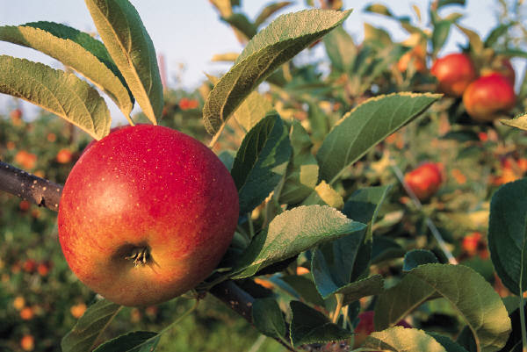
Welcome to the first month of our new school year. Everyone is having fun learning, playing, singing and making new friends. Thank you for sharing your child with us each day.

Reminders:
- Children should wear tennis shoes or closed toe shoes. The playground is covered in bark and open toe shoes get bark inside.
- Each child needs a change of clothes in a Ziploc bag in the event of an accident.
- Please label all lunch boxes, cups, and thermos.
- Please keep your car tag posted until your child is placed in the car.

Chapel:
- Pastor Rusty has begun chapel with all the children. They love his excitement, learning new songs, and hearing a Bible Story.

Music:
- Mrs. Johnston began music this week. The children are learning “The Welcome Song”, “Gray Squirrel” and “If You’re Happy and You Know It”. Perhaps they will sing it for you at home.

Many Thanks to all of the parents for supplies sent in with your child. We appreciate your generosity. It is nice to begin the year with plenty of supplies.

Car Moms & Dads, thank you for helping each morning as we begin our day. You help our day begin smoothly.

Happy September Birthday to:
- Klaire Peterson 9-18
- Eldad Solomon 9-24
- Caroline Tamez 9-25
- Madison Kirkpatrick 9-26

Inclement Weather: Please listen to local news stations regarding the impending arrival of Hurricane Florence. (Pray she returns to sea.) If the Charlotte Mecklenburg School System is closed Preschool & T-K will also be closed. Remember to stay safe.

Save the Date:
Scholastic Book Fair – November 5-9,2018 and on Sunday, November 11, 2018.

Every good thing you do creates ripples that you may or may not see. Do them anyway.

